**1.**

using System;

using static System.Console;

namespace DayDreaming

{

/*

* A program that converts user input from minutes to hours to

* display how much they daydream at work.

*/

// Written By: Sam Graham, Tampa, FL, USA

// Written On: 1/24/2019

class DayDreaming

{

const int MINUTES_TO_HOURS = 60;

static void Main(string[] args)

{

Write("How many minutes are you daydreaming at work? ");

int minutes = Convert.ToInt32(ReadLine());

WriteLine("Wow, that's {0} hours and {1} minutes!",

Convert.ToString(minutes / MINUTES_TO_HOURS),

Convert.ToString(minutes % MINUTES_TO_HOURS));

}

}

}

**Output:**

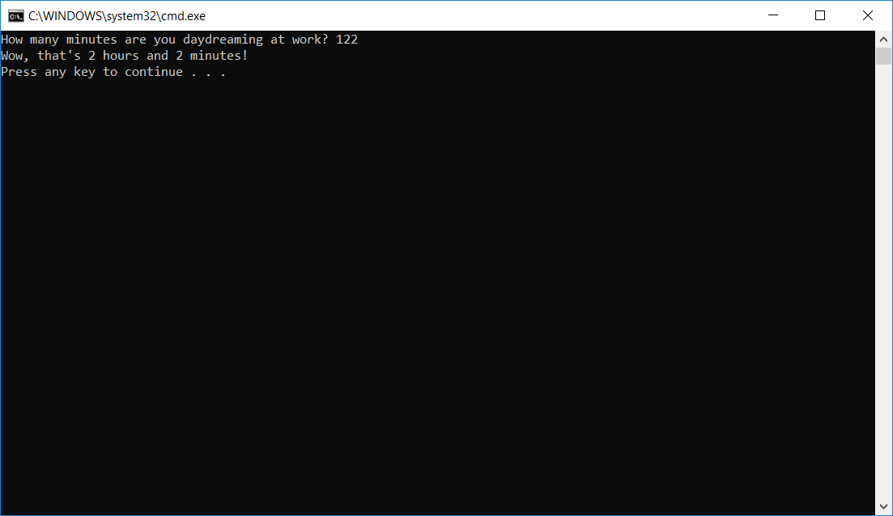

**2.**

using System;

using static System.Console;

namespace COP_2360_A2

{

/* This program asks the user to input the number of tests taken and what was

* made on each test. It verifies the user inputs valid information. The

* calculated average is displayed to the nearest tenth.

*/

// Written by: Sam Graham

// Written On: 1/26/2019

class ScoreMonger

{

static void Main(string[] args)

{

int numberOfTests = 0;

string errorNotPositiveNum = "Please enter a positive number";

string errorNotWholeNum = "Please enter a numeric whole number";

while (numberOfTests == 0)

{

WriteLine("How many tests did you take? ");

try

{

numberOfTests = Convert.ToInt32(ReadLine());

if (numberOfTests <= 0)

{

WriteLine(errorNotPositiveNum);

numberOfTests = 0;

}

}

catch

{

WriteLine(errorNotWholeNum);

numberOfTests = 0;

}

}

int[] test = new int[numberOfTests];

int sumTotalOfTests = 0;

for (int i = 1; i <= numberOfTests; i++)

{

string testNumber = "test " + Convert.ToString(i);

Write("What did you make on {0}? ", testNumber);

try

{

test[i - 1] = Convert.ToInt32(ReadLine());

if (test[i - 1] < 0)

{

WriteLine(errorNotPositiveNum);

i--;

}

}

catch

{

WriteLine(errorNotWholeNum);

i--;

}

}

for (int j = 0; j <= (numberOfTests - 1); j++)

sumTotalOfTests += test[j];

WriteLine("Your average score is {0}",

((double)sumTotalOfTests / numberOfTests).ToString("F1"));

}

}

}

**Output:**

